19.5: a)
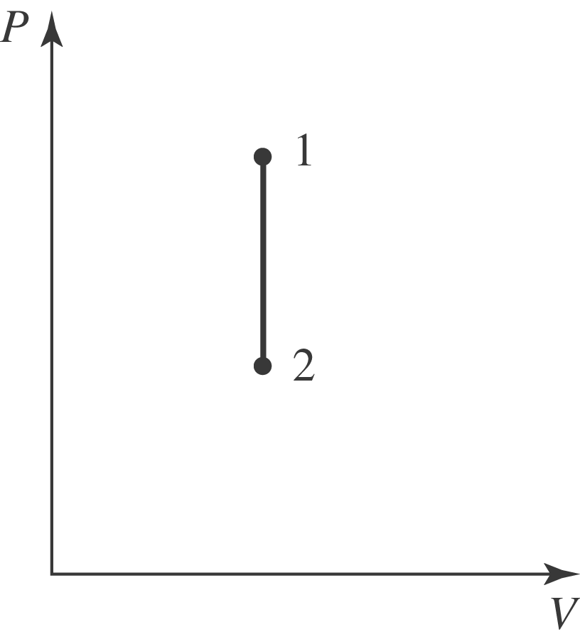
b) At constant volume, 